Interview of Curt Bonk, by Marko Rissanen, Kuopio Magazine (during visit to University of Kuopio), Kuopio, Finland, August 2003

1) In your own words: who are you?

Curt Bonk. A former accountant turned educational psychologist who now spends a lot of time teaching people to teach online. I like to experiment in my own teaching and share it with others. I develop online learning software and also conduct research in this area. Many of my presentations and publications are available at TrainingShare.com and PublicationShare.com, respectively.

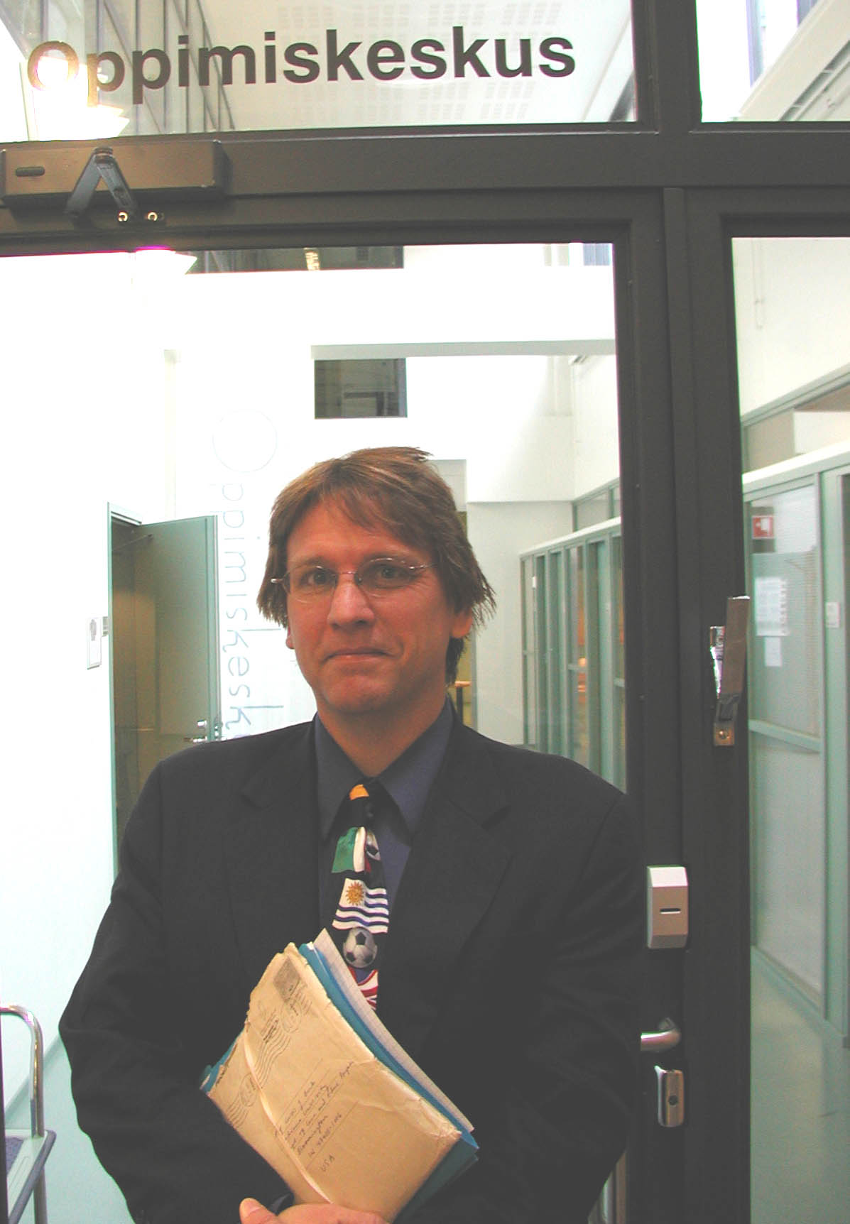

2) Greatest accomplishments? (in private life and in work)

Running the Chicago Marathon last year after 30+ years of preparation. I am not fast, but hey, I did complete it. I did nearly 100 talks around the globe last year and I tried running at each place I visited in order to see more of the city or university campus and be relaxed for my talk. It also helped get me in shape for the marathon. In my professional life, I would say my recent recognitions in distance education (both State and national) are things I was happy to receive the past two years. Last year, I got something called at CyberStar award from the Indiana Information Technology Association. It was a tuxedo affair and with big screen introductions so that probably ranks pretty high, especially since my family could be there.

3) Why are (were) you in Kuopio?

To talk to instructors, students, and administrators about teaching online. There is a growing interest in how to teach on the Internet. Many people are interested in how to motivate people online and increase learner collaboration and interaction. I was in Kuopio to share some of the things we do in these areas. I found the university extremely impressive and on the go in the area of e-learning. And what a beautiful setting!

4) How should we be prepared to "The perfect storm"?

I think we can look for pedagogical techniques that might become more prevalent with the emergence new technologies such as mobile and wearable technologies. Some technologies may allow for greater mentoring opportunities. Some will foster the sharing of content and online teaching techniques. And still other technologies will foster greater idea exchange and evaluation. Instructors must be made aware of the options that emerging technology provide. Second, there will be enormous learner demands within e-learning. As a result, there should be programs developed not just for instructors to teach online but also for students to know what the expectations of online classes tend to be. Students need e-learning training in order to more effectively take and complete online
courses. Such training is vital since the number of students taking online courses will only increase during the next decade. Third is enhanced pedagogy. We must train instructors how to motivate online students and address their individual learning styles or needs. There are hundreds of pedagogical techniques for the Web, most of which instructors are simply not aware of. As I stated at my talk, the Emerging technologies, Enormous learner demands, and Enhanced pedagogy, for the Perfect E-Storm.

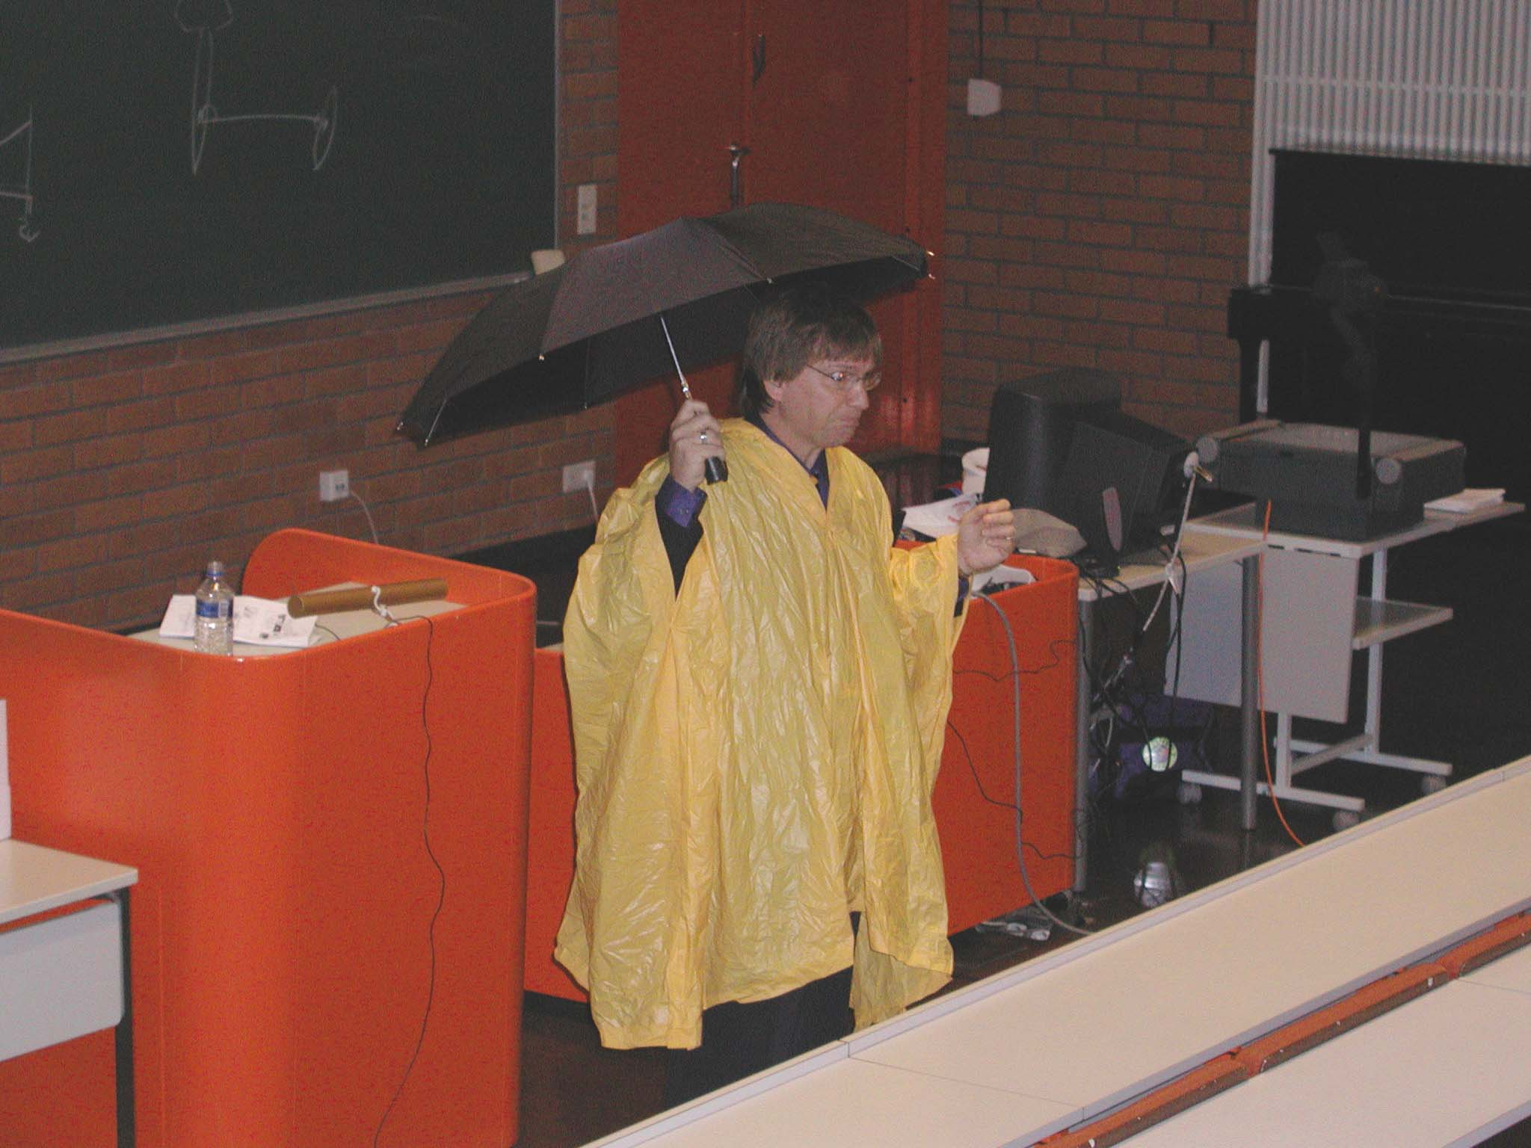

5) R2D2 -teaching method, what is that?

It is a technique that I embed into all my classes. I want my students to Read a lot in all my courses, especially early in the course. Second, I want them to Reflect on those readings, my lectures, and their personal explorations. Third, I want them Display their learning with visual maps, taxonomies, or timelines. Finally, I want my students to Do something with the knowledge and skills they are gaining. Most students appreciate a chance for active or hands-in learning. I have those four types of activities in all my courses. Some students tend to be auditory or verbal learners, some prefer reflective or observational learning, some are visual learners, and some want hands-on or kinesthetic experiences. This model of instruction maps closely the most famous learning style inventories methods such as the one by David Kolb.

6) Give a tip (that you would have needed when you were a novice teacher) to those who teach online courses

Start small. Take low risks and try strategies that take little time. But, always try one new thing every semester. And then share the results with colleagues.

